Assignment 16: Introduction to WAN Technologies
Student Name | Shreya Panchal
Topic | Definition of WAN, Types of WAN Connections, WAN Devices: CSU/DSU, WAN Aggregators

Theory Overview

1. Definition of WAN (Wide Area Network)
A Wide Area Network (WAN) is a telecommunications network that extends over a large geographical area, such as a city, country, or even the entire globe. Unlike Local Area Networks (LANs) that connect devices within a limited area like a home or office, WANs connect multiple smaller networks (LANs) together. This allows businesses and individuals to communicate and share data across long distances. The internet itself is the largest and most well-known example of a WAN.

2. Types of WAN Connections
WAN connections can be categorized based on how data is transmitted across the network:
- Leased Lines: Dedicated, point-to-point digital circuits provided by a service provider. They offer guaranteed bandwidth and high security but are expensive.
- DSL (Digital Subscriber Line): A technology that uses existing regular telephone lines to transmit high-speed digital data. It is widely used for residential and small business internet access.
- MPLS (Multiprotocol Label Switching): A high-performance telecommunications network technology that directs data from one node to the next based on short path labels rather than long network addresses, making it highly efficient for enterprise networks.

3. WAN Devices
- CSU/DSU (Channel Service Unit/Data Service Unit): A digital-interface device used to connect a router to a digital circuit, such as a T1 or T3 line. It handles signaling, clocking, and translates data frames from the LAN format to the WAN format.
- WAN Aggregator: A dedicated network appliance or high-end enterprise router that aggregates multiple WAN links (like MPLS, Broadband, LTE/5G) into a single, cohesive, high-capacity connection. It optimizes traffic flow, provides redundancy, and ensures high availability.

Tasks & Answers

Task 1: WAN Connections Comparison Table
Create a table comparing at least three types of WAN connections (such as leased line, DSL, and MPLS) with columns for speed, cost, and typical use cases.
Answer:
WAN Connection Type | Speed / Bandwidth | Cost Structure | Typical Use Cases
Leased Line | Symmetric speeds (typically 10 Mbps to 10 Gbps+), highly reliable with strict SLAs. | Very high (fixed monthly cost regardless of usage). | Interconnecting corporate headquarters, data centers, and critical server environments requiring constant, dedicated bandwidth.
DSL (Digital Subscriber Line) | Asymmetric speeds (download up to 100 Mbps; upload lower, e.g., 10–20 Mbps). | Low to moderate (cost-effective broadband). | Small and medium businesses (SMBs), remote branch offices, and home office environments (telecommuting).
MPLS (Multiprotocol Label Switching) | High and scalable speeds (2 Mbps to 10 Gbps), highly predictable traffic prioritization (QoS). | High (cheaper than dedicated leased lines but more expensive than public internet broadband). | Large enterprise networks connecting multiple regional offices requiring reliable VoIP, video conferencing, and ERP applications.

Task 2: CSU/DSU Network Diagram & Role Description
Draw a labeled diagram (on paper or using any drawing tool) showing how a CSU/DSU connects a router to a WAN service provider, and explain the role of each device in 2-3 sentences.
Answer:
Diagram Visual Representation:
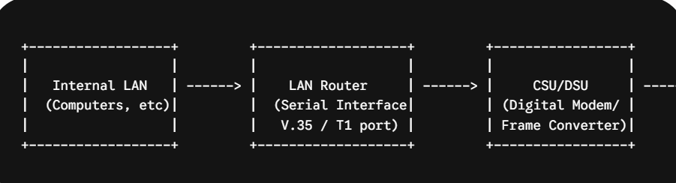
Role Explanations:
- LAN Router: The router functions as the gateway for local devices, determining the best path for data packets to leave the local network and routing them toward the WAN interface. It handles Layer 3 network addressing and protocols.
- CSU/DSU: The Channel Service Unit/Data Service Unit acts as a translator between the router's digital communication standards and the telecommunication network's signaling architecture. It handles line conditioning, timing/clocking, and error monitoring over the digital WAN circuit.
- WAN Service Provider: This is the telecom carrier's infrastructure that physically transports the data across long geographical distances to its ultimate destination using fiber-optic or copper transport lines.

Task 3: Real-World WAN Application Examples
List three real-world examples of popular apps or services (like IRCTC, WhatsApp, or Zomato) that rely on WAN connections, and briefly describe how WAN enables their functionality.
Answer:
IRCTC (Indian Railway Catering and Tourism Corporation):
How WAN enables it: IRCTC operates a massive centralized ticketing and reservation database server. When a user from any part of India attempts to book a train ticket via their phone or local booking counter, the request travels across a Wide Area Network (WAN) to reach the central database. WAN ensures real-time synchronization so that a seat booked in Mumbai is instantly updated and marked unavailable for a user searching in Delhi.
WhatsApp:
How WAN enables it: WhatsApp relies completely on global WAN networks (the public Internet) to connect its distributed cloud servers to worldwide users. When a message, photo, or voice note is sent, it is broken into packets and routed over global carrier networks spanning continents. This allows instantaneous cross-border peer-to-peer communication, media delivery, and real-time VoIP voice/video calls.
Zomato:
How WAN enables it: Zomato serves as a live bridge connecting three distinct stakeholders: customers, restaurant merchants, and delivery partners. WAN connections allow the application to coordinate GPS tracking data from the delivery driver's mobile network, transmit order placements instantly to the restaurant's local system, and update order status milestones live on the customer's device across varying cellular and broadband networks.

Task 4: WAN Aggregator Analysis
Research online and find an image or data sheet of a physical WAN aggregator device used in enterprise networks. Paste the image or link, and write two key features of that device.
Answer:
Example Physical Device: Cisco Catalyst 8500 Series Edge Platforms (e.g., Cisco C8500-12X4QC).
Datasheet Reference Link:
https://www.cisco.com/c/en/us/products/routers/catalyst-8500-series-edge-platforms/datasheet.html
Two Key Features:
- High-Performance Multi-Gigabit Aggregation: It supports multi-gigabit routing throughput with high-density ports (such as 10GbE, 40GbE, and 100GbE interfaces), enabling corporate data centers to aggregate thousands of remote branch office WAN lines seamlessly.
- Integrated SD-WAN & Advanced Security: It features built-in hardware-accelerated encryption and advanced software capability for Secure Access Service Edge (SASE), cloud security, and intelligent path selection across multiple links (MPLS, internet, LTE) to optimize app performance.

